**CIS 549 Project 3 Report**

**Gordon Finn & Paul DeSantis**

**Question #1**

Network Topology for 1UE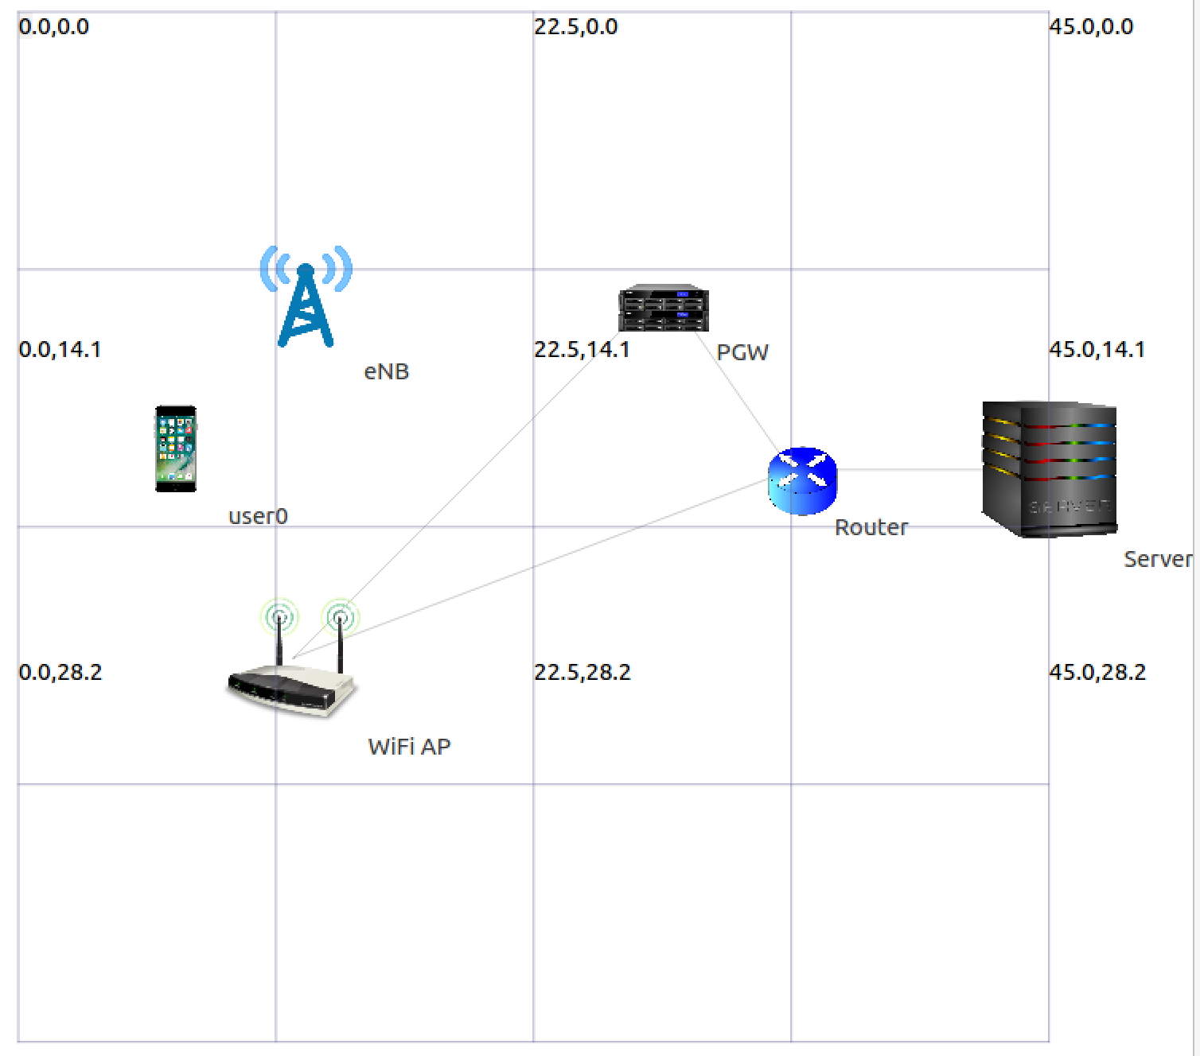

Network Topology for 20 UE

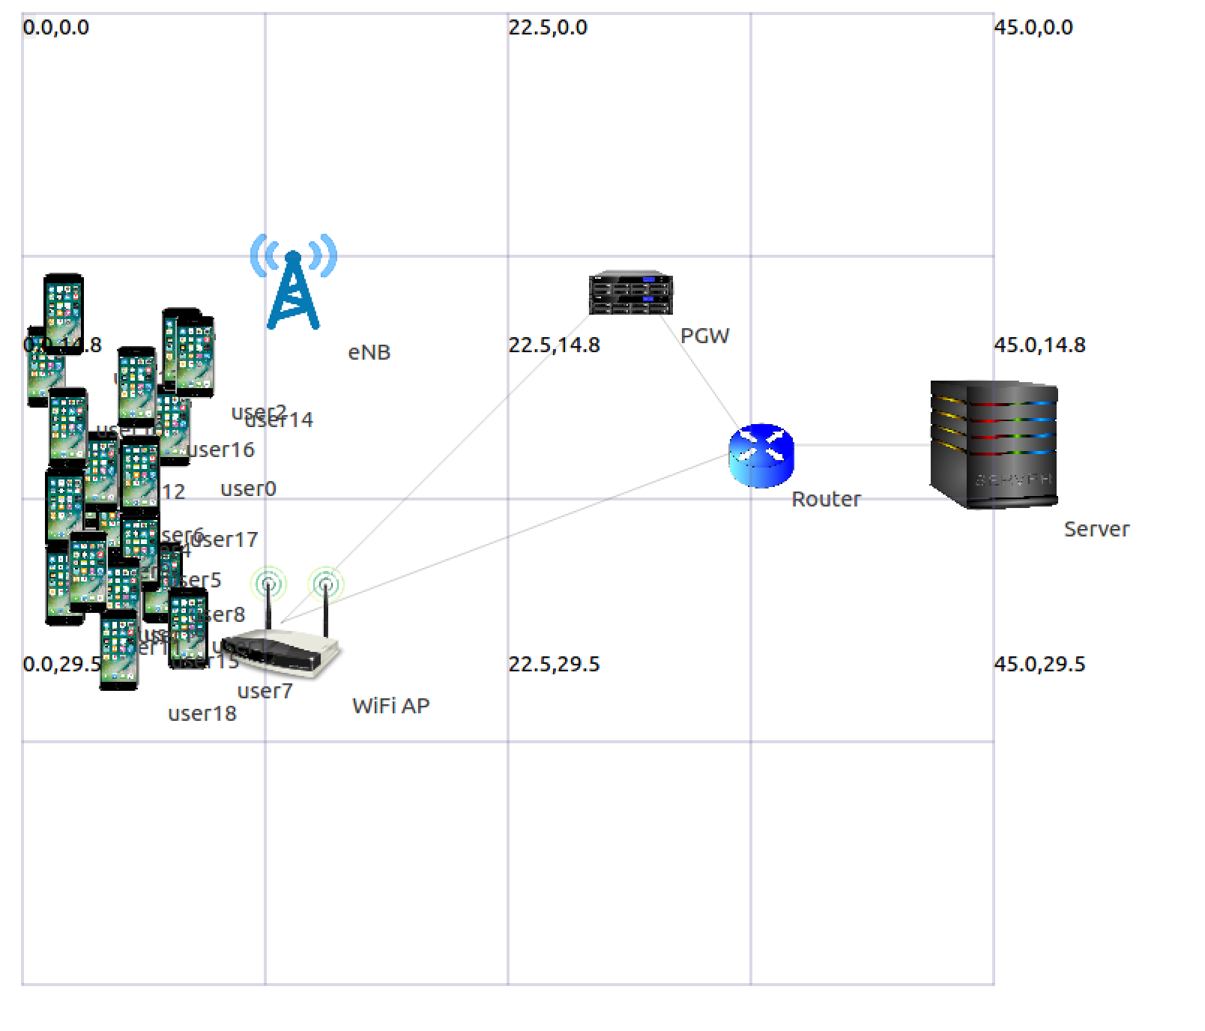

**Question #3**

|  |  |  |  |  |  |  |  |  |
| --- | --- | --- | --- | --- | --- | --- | --- | --- |
| RTT(ms) | RWND (Bytes) | MCS | 1 UE | | 3 UE | | | |
| Per UE | | Per UE | | System level | |
| Wi-Fi TCP | | Wi-Fi TCP | | Wi-Fi TCP | |
| Peak (Mbps) | Avg (Mbps) | Peak (Mbps) | Avg (Mbps) | Peak (Mbps) | Avg (Mbps) |
| 30 ms | 64000 | HtMcs1 | 14.67 | 11.11 | 12.64 | 7.12 | 24.08 | 21.23 |
| 200 ms | 64000 | HtMcs1 | 5.04 | 2.48 | 5.04 | 2.63 | 13.66 | 6.94 |
| 30 ms | 1024000 | HtMcs1 | 23.97 | 21.04 | 23.86 | 13.70 | 23.86 | 20.68 |
| 200 ms | 1024000 | HtMcs1 | 23.86 | 16.32 | 23.97 | 11.34 | 23.97 | 16.78 |
| 30 ms | 64000 | HtMcs7 | 16.80 | 15.38 | 16.58 | 13.79 | 46.59 | 41.36 |
| 200 ms | 64000 | HtMcs7 | 5.04 | 4.59 | 5.04 | 3.00 | 15.12 | 7.73 |
| 30 ms | 1024000 | HtMcs7 | 70.34 | 25.80 | 114.46 | 61.76 | 114.46 | 92.27 |
| 200 ms | 1024000 | HtMcs7 | 113.57 | 72.70 | 81.76 | 27.32 | 114.13 | 66.66 |

**Question #4**

|  |  |  |  |
| --- | --- | --- | --- |
| RTT | MCS | 1 UE | |
| System Level | |
| Wi-Fi UDP | |
| Peak (Mbps) | Avg (Mbps) |
| 30 ms | HtMcs1 | 25.20 | 25.09 |
| 200 ms | HtMcs1 | 25.09 | 25.09 |
| 30 ms | HtMcs7 | 121.97 | 121.73 |
| 200 ms | HtMcs7 | 121.97 | 121.73 |